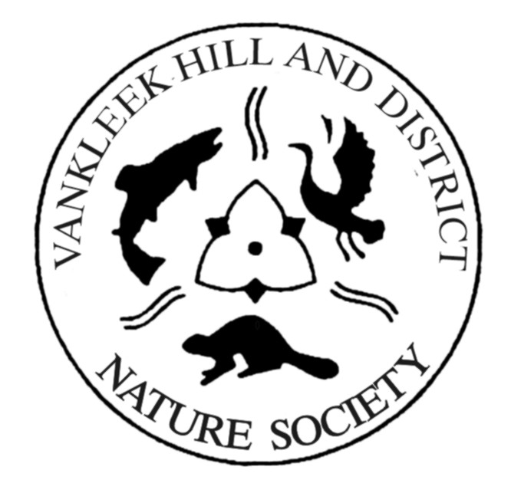
‘’Conservation through Education’’

Vankleek Hill & District Nature Society
2019 Youth Summit
Application Document
September 20 – 22, 2019

A sponsored event in cooperation with Ontario Nature and the Youth Council of Ontario Nature

Hosted by Ontario Nature’s Youth Council, the summit has a strong youth leadership component and council members themselves lead many of the activities!

www.vankleekhillnaturesociety.org
www.ontarionature.org/youthsummit
ONTARIO NATURE YOUTH SUMMIT

Background

The Vankleek Hill and District Nature Society (VKHDNS) was established in 1977 with the purpose of educating and encouraging youth to be more engaged in the area of the environment affecting nature and to learn about the various aspects that impact the world we live in. The motto of the Society is “Conservation through Education”

In 2010, Ontario Nature (provincial organization with over 150 local community conservation groups), developed a weekend-long Youth Summit. The annual event aims to develop an understanding of provincial biodiversity and environmental issues. It also aims to inspire the drive and ability among some 100 summit participants to take action and lead in their own communities. Ontario Nature’s Youth Council, comprised of 35 young people across the province, work alongside Ontario Nature to plan and host the weekend.

Youth Summit for Biodiversity and Environmental Leadership

When: September 20 – 22, 2019
Where: YMCA Geneva Park located on Lake Couchiching in Orillia, ON
For: 100 young people grades 9 – 12 from across the province

Some highlights to look forward to at the Youth Summit:

- Interactive workshops and activities on topics including medicinal plants, every-day sustainability, climate action, how to lead a nature hike, birdwatching, freshwater life, pollinators and much more
- A regional networking forum for participants to connect and develop plans with local youth
- A wonderful venue on Lake Couchiching, complete with hiking trails, early-morning canoeing and campfires
- A high-energy Great Group Challenge that will have you facing off in eco-inspired challenges
- Meet diverse young leaders with similar interests from across Ontario!

What`s included?

- Meals: Six meals beginning with dinner on Friday and ending with lunch on Sunday, with snacks and beverages available throughout the weekend
- Accommodations: Rooms at Geneva Park are suite-style with two summit participants per room with a 3-piece bathroom

Sponsorship Program Guidelines

- Sponsor of two (2) youths from our area based on the following criteria
- Youth between the ages of 14 and 19 years old
- Attending a secondary school Grades 9 through 12
- The candidates would be selected based on the information on the application form, answers to the questionnaire and possibly an interview process conducted by 2 members of the VKHDNS

- Students from area secondary schools are invited to submit their application to:

Christine Trudeau
VP of the Vankleek Hill and District Nature Society
cristeentb5@gmail.com

or
Selection Committee – Youth Summit
Vankleek Hill and District Nature Society
P.O. Box 366, Vankleek Hill, ON K0B 1R0

- The VKHDNS will sponsor 2 students for attendance and transportation costs
(VIA Train round trip from either Cornwall to Toronto or Ottawa to Toronto) by the most economical means. We encourage students to travel together.

- Application deadline is September 6, 2019

- Final selection and announcement of the two students will be done on
September 12

2019 YOUTH SUMMIT APPLICATION – PART 1

NAME OF APPLICANT _________________________________________________
DATE OF BIRTH ______________________________
(must be between the ages of 14 -18 at time of application)
ADDRESS __________________________________________________________
TOWN ______________________________ POSTAL CODE ______________
PHONE(S) H:_____________________ C: ________________________________
EMAIL ADDRESS _____________________________________________________

GRADE LEVEL (as of September 1, 2019) ___________________________________
SECONDARY SCHOOL /INSTITUTE _______________________________________
******
NAME OF PARENT/ GUARDIAN __________________________________________
ADDRESS ___________________________________________________________
TOWN _______________________________ POSTAL CODE ______________
PHONE(S) H:_______________________ C: _______________________________
EMAIL ADDRESS _____________________________________________________

SIGNATURE FOR CONSENT

I consent that _______________________________applies for the Youth Summit and if chosen can attend the event from September 20 to 22, 2019.

Signature __________________________________________

DATED __________________________________________

2019 YOUTH SUMMIT APPLICATION – Part 2

Please answer the following questions to be considered attending the Youth Summit.

- The environment is not a high priority of governments at various levels, whether they are at the municipal, provincial or federal level. List a number of activities that you would do to heighten the awareness of environmental issues and concerns.

- What are in your mind, the top 5 environmental issues facing society today?

- What positive decisions or changes have you done in the past to preserve or enhance the natural environment?

- Based on the information obtained via the internet or other means, how do you think you would benefit from attending the Youth Summit?

