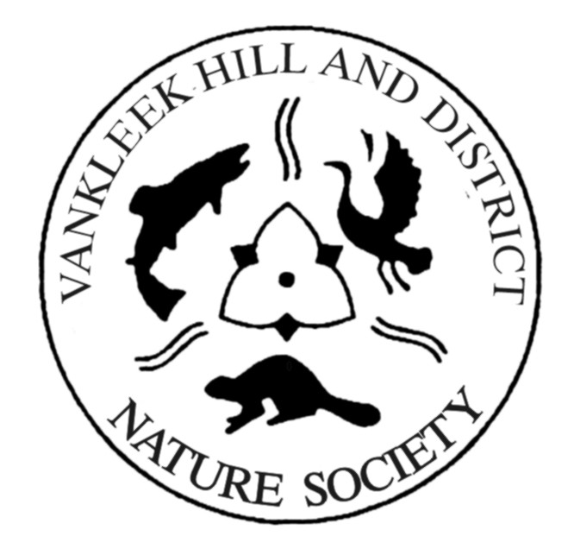

Conservation through Education

Donations or Membership Application / Renewal

Please complete and return with your cheque made payable to:

Vankleek Hill and District Nature Society
P.O. Box 366, Vankleek Hill, ON, K0B 1R0

Name: _______________________________________________

Address:_____________________________________________

City:_______________________________ Province: _______

Postal Code: ______________ Phone: __________________

Email:________________________________________________

Membership Fee $10 per person
Number of memberships: _____ Donation: $__________

Income tax receipts are issued for the full amount of membership fees, and for donations of $20 or more (National Revenue Number 89065 5947 RR0001).

